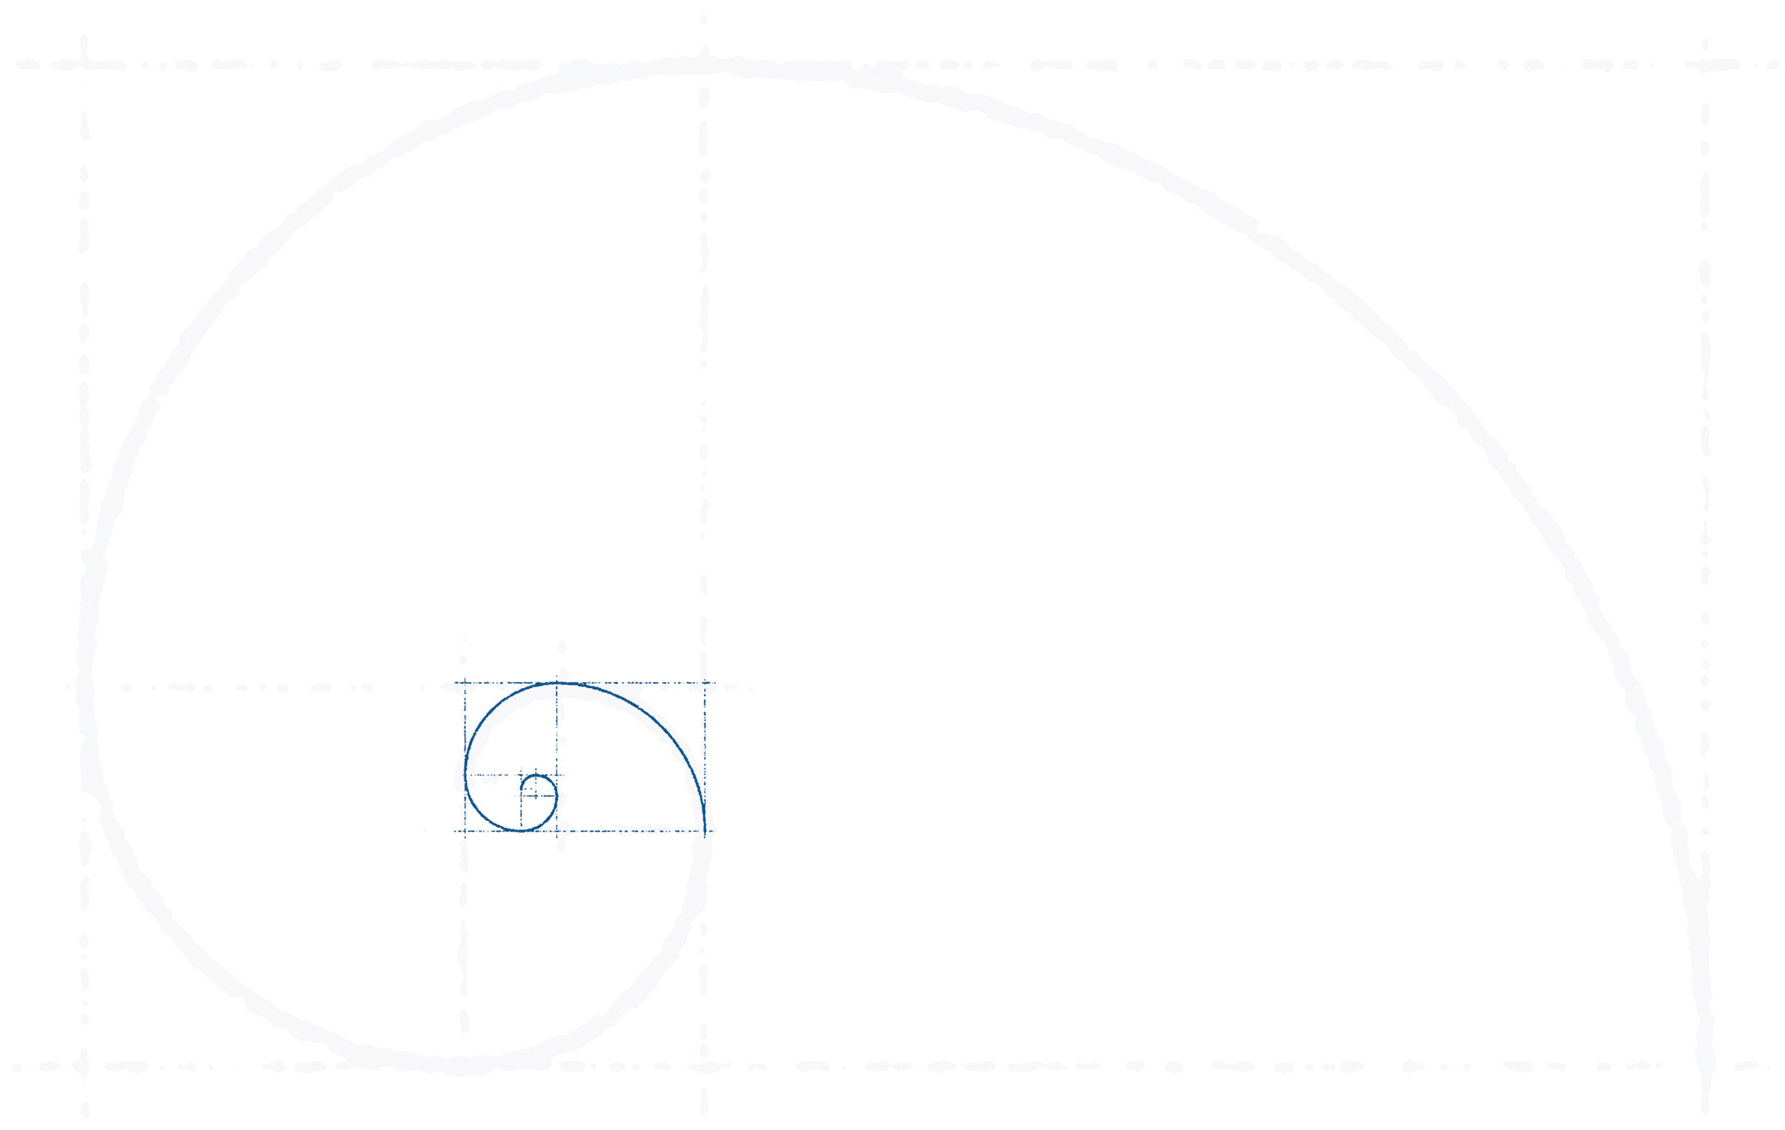
155 Rochester Street, Costa Mesa, CA 92627, USA
Phone: 949.515.4194 | Fax: 949.515.2984
CA Lic. #0E70906 | www.artisanbonding.com
Artisan Bonding
& Insurance Services, LLC

CALIFORNIA INSURANCE BROKER BOND

Artisan Bonding would like to thank you for your interest in obtaining your bonds through our agency.

The application attached must be completed in full and properly signed per the instructions. If married, your spouse must also sign as an Indemnitor. This is a surety requirement. You may fax the application to us to begin the process. Be sure to mail the original application with “wet” signatures to our office. Upon receipt, we will forward the bond to you for filing.

If you would like your bond sent via overnight mail, please include your FedEx account number or you can include $15.00 to your premium payment.

Bond Amount: $10,000.00 Premium: $110.00/3 years

------------------------------------------------------------------------------------------------------------------------------------

Payment Options:

___ Check enclosed. Please make payable to Artisan Bonding & Insurance Services, LLC

___ Credit Card: ___Master Card ___Visa ___add $15.00 for overnight fee

___ check here to show you understand that a 4% service fee will be added for all credit card payments.

Name as is appears on card: ______________________________________________________

Billing address for credit card: ____________________________________________________

Credit Card Number: _________________________________________________CCV______

Expiration Date:___________________ Email: ___________________________________

Signature:_____________________________________________________________________

(My signature above authorizes Artisan Bonding & Insurance Services LLC or its subsidiaries to charge my credit card for services/products rendered or to be rendered.)

